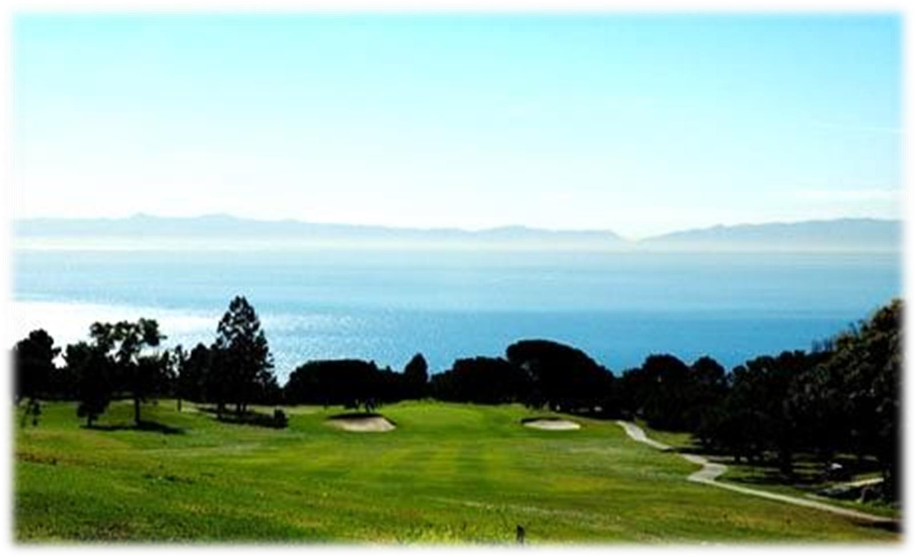

***GOLF TOURNAMENT***

**June**

**12**

**6 ,**

**, 2023**

Los Verdes Country Club

7000

W Los Verdes Drive, RPV CA

90275

Phone

–

310.377.7370

Entry Fee: $125 per golfer: Includes Green Fees, Cart, Contest Awards, $20 donation to JEMS, Coffee & Quick start.

*After* June 5, please *add* $10 late fee to Entry Fee.

Registration Open : 8:00 AM; Announcements – 9:45 AM

# Specials - $10,000 Hole in One. Putting, Chipping and Bunker Contests

**LA County has raised cost of golfing so no usual breakfast, instead coffee, assorted pastries. Juices, fruit are included this year. Please stay in touch by emailing** [**revsamt29@gmail.com**](mailto:revsamt29@gmail.com) **at any time. [ ] Mark here if you need to pay later at the Course. Thank you for your understanding**

## - - - - - - - - - - - - - - - - - -submit the below registration form - - - - - - - - - - - - - - - - - - -

**Mount Hermon Scholarship Golf Registration Form**

**NAME ADDRESS EMAIL/PHONE**

1 contact person

2

3

4

Sponsorships: ( ) Gold: $500 ( ) Silver $250 ( ) Tee: $150 each

( ) Donation of $100 in Memory of your loved one: Name__________________________________

Total Payment Enclosed: $_____________ $___________ $________________ $_____________ = $_________

Registration Sponsorship Donation Late Fee TOTAL

Please send your check and this form to JEMS, P,O. Box 86047, Los Angeles, CA 90086-0047, Attn: Rev. Sam Tonomura, no later than **Monday,** **JUNE 5, 2023**. *After* add $10 late fee to Entry Fee. Thank you for your faithful support**. Revised 5.12.23**